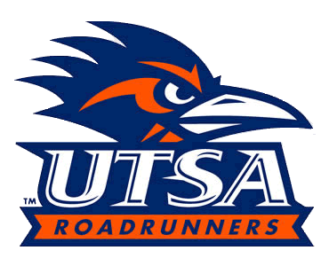
UTSA Athletics Marketing Internship
UTSA Athletics Internship will provide hands-on experience in Division 1 college athletics. While working with UTSA Athletics Marketing students will have the opportunity to learn basic marketing operations from idea generation to execution for all UTSA fall, winter and spring athletic events. The student will assist in planning and implementing marketing plans for all sports including Football, Volleyball, Soccer, Women’s Basketball, Men’s Basketball, Baseball, Softball, Tennis and Track & Field. Students will have the opportunity to assist in running game day operations. Students may also play a role in select special events and planning of Rowdy Runners Kids Club events.
Job Description:
- Assist in the execution of Football, Men's and Women's Basketball, and Olympic Sports marketing campaigns
- Game day responsibilities include: serving as promotions assistant at table set-up, social media activation, sponsor fulfillment, in-game promotion implementation, group night activities coordinator
- Coordinate game day elements for Football, Men's and Women's Basketball, and Olympic Sports that includes but not limited to: compile band & cheer pass lists, parking lists, schedule anthem performers, scheduling of internal & external halftime and TO performers.
- Responsible for campus marketing efforts to promote all sporting events (A frames, campus announcements, tabling events, assisting at Game Week Wednesday’s with Rowdy Crew).
- Responsible for grassroots marketing efforts with corporate sponsors and within the local community (distributions of marketing collateral i.e. posters, schedule cards, etc.).
- Assist with the Rowdy Runners Kids Club - solicit members, arrange and execute events, etc.
- Other duties and special projects as assigned by Assistant AD - Marketing and Marketing Associates
- Adhere to NCAA, C-USA and University of Texas – San Antonio compliance rules

Interns will report to and be evaluated by the Marketing Associate.
Please note this is an unpaid position.

For more information or questions contact:
Stanley Frazier
Marketing Associate, UTSA Athletics
stanley.frazier@utsa.edu
O: 210-458-8226
C: 210-328-0970

